Title: Enhancing User Experience and Sales with E-Commerce Recommendation Systems

Abstract:
E-commerce recommendation systems have become integral to online shopping platforms, offering numerous advantages for both businesses and consumers. This report explores the pros of implementing recommendation systems in e-commerce, highlighting how they can enhance user experience, increase sales, and drive customer engagement.

1. Introduction

In the highly competitive world of e-commerce, businesses are constantly seeking innovative ways to improve user experience and boost sales. One such innovation is the implementation of recommendation systems. These systems leverage data and algorithms to provide personalized product recommendations to users. This report explores the advantages of e-commerce recommendation systems, shedding light on their potential to revolutionize online shopping.

2. Personalized Shopping Experience

Improved User Engagement: E-commerce recommendation systems create a highly personalized shopping experience. By analysing user behaviour and preferences, these systems suggest products that are more likely to align with the customer's interests, resulting in increased engagement and longer time spent on the platform.

Enhanced Customer Satisfaction: Shoppers appreciate relevant product recommendations, as it saves them time and effort in searching for items. This level of personalization enhances customer satisfaction and encourages repeat business.

3. Increased Sales and Revenue

Upselling and Cross-selling: One of the primary advantages of recommendation systems is their ability to suggest complementary or higher-value products. This leads to increased sales through both upselling (encouraging customers to buy more expensive items) and cross-selling (suggesting related items).

Reduced Cart Abandonment: Personalized recommendations can help reduce cart abandonment rates. By suggesting items that complement the products in a customer's cart or offering relevant discounts, customers are more likely to complete their purchase.

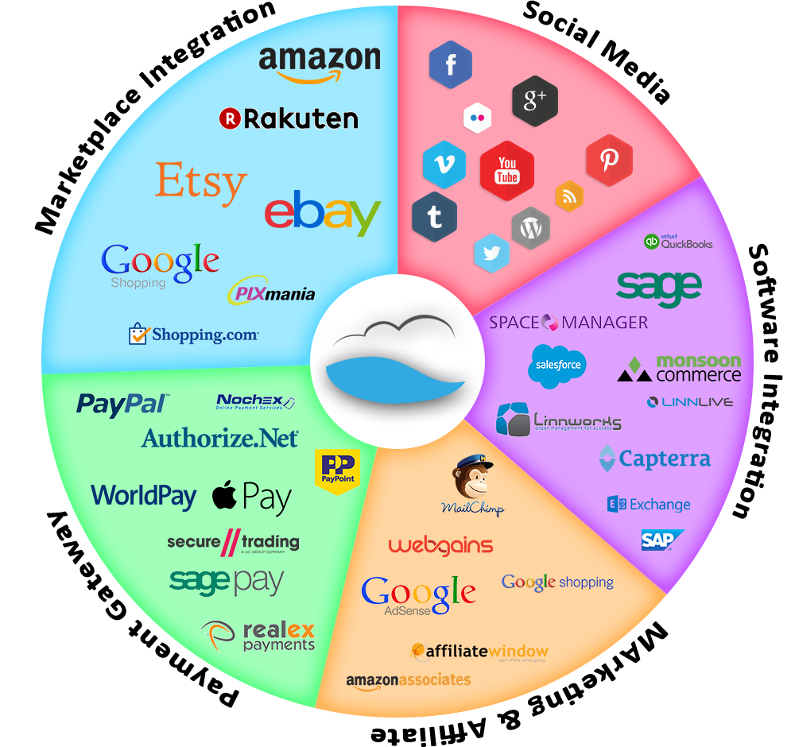

4. Better Inventory Management

Inventory Turnover: E-commerce businesses can optimize their inventory management by promoting specific products through recommendation systems. This can help reduce excess inventory and increase the turnover rate, leading to cost savings.

Clearing Stale Inventory: systems can also be used to clear out stagnant or seasonal items by suggesting them to users who might find them relevant.

5. Enhanced Customer Retention and Loyalty

Customized Content: E-commerce recommendation systems can suggest not only products but also content such as blogs, articles, and videos that align with the user's interests. This keeps customers engaged and fosters a sense of community around the platform.

Membership Programs: Personalized recommendations can be used to promote loyalty programs and memberships, encouraging users to become long-term customers.

6. Data-Driven Insights

User Behaviour Analysis: Recommendation systems collect a wealth of data on user behaviour, allowing businesses to gain deep insights into customer preferences, browsing patterns, and purchasing habits. This data can inform marketing strategies and product development.

A/B Testing and Optimization: E-commerce recommendation systems allow businesses to experiment with different recommendation algorithms, fine-tuning the system to maximize its effectiveness in boosting sales and user engagement.

7. Snapshots
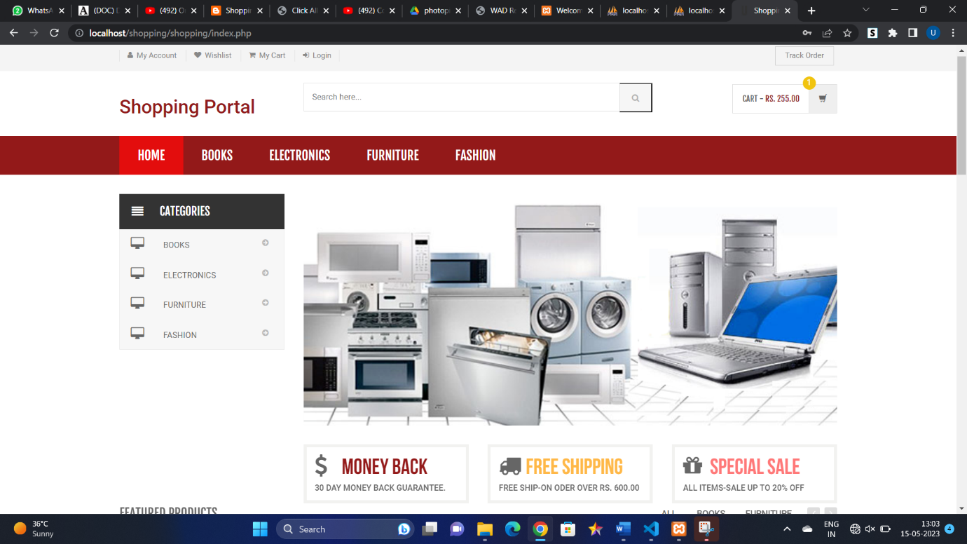
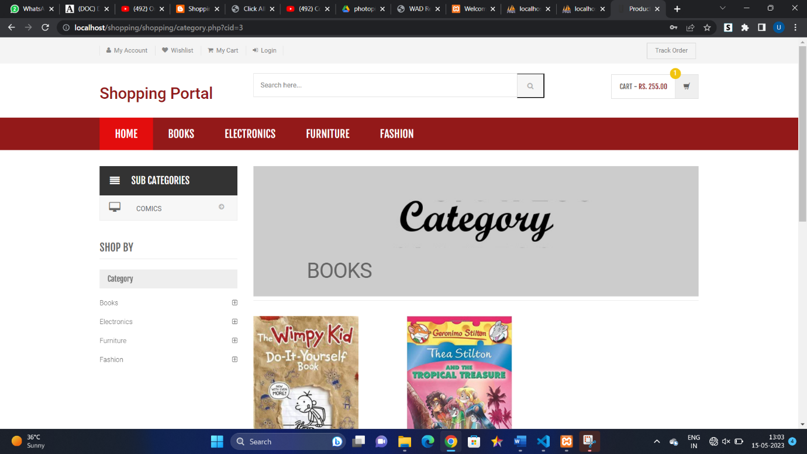
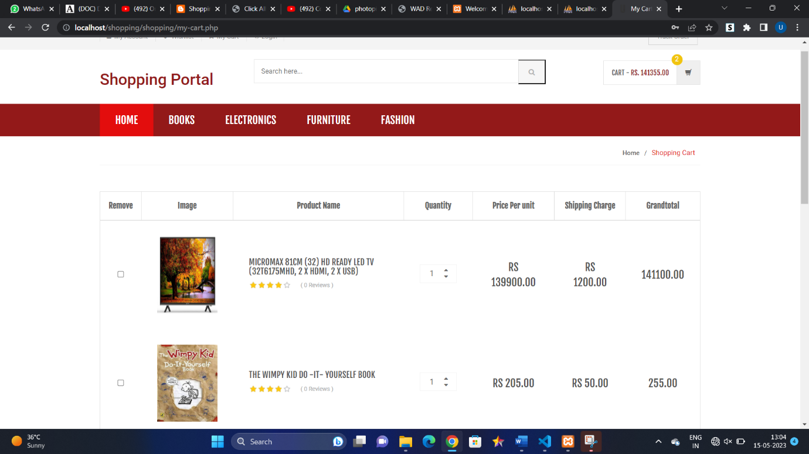

8. Conclusion

E-commerce recommendation systems are a powerful tool for online retailers, providing a range of benefits. They create a more personalized shopping experience, increase sales and revenue, improve inventory management, enhance customer retention, and provide valuable data-driven insights. As online shopping continues to evolve, businesses that invest in recommendation systems are likely to enjoy a competitive advantage and continued growth in the e-commerce landscape.

